**CP Club 365Days Challenge**

**Programming language – C++**

**Problem Statement**

https://practice.geeksforgeeks.org/problems/missing-number-in-array1416/1?page=1&curated[]=1&sortBy=submissions

**Your Code**:

// 0x65Day of 0x365Days challenge

// VEDANT BHARAD

// 21-12-2022

//{ Driver Code Starts

// Initial template for C++

#include <bits/stdc++.h>

using namespace std;

// } Driver Code Ends

// User function template for C++

class Solution{

    public:

        int MissingNumber(vector<int>& array, int n) {

            // Your code goes here

            sort(array.begin(), array.end());

            for(int loop=0; loop<array.size(); loop++)

            {

                if(array[loop]!=(loop+1))

                {

                    return loop+1;

                }

            }

            return n;

        }

};

//{ Driver Code Starts.

int main() {

    int t;

    cin >> t;

    while (t--) {

        int n;

        cin >> n;

        vector<int> array(n - 1);

        for (int i = 0; i < n - 1; ++i) cin >> array[i];

        Solution obj;

        cout << obj.MissingNumber(array, n) << "\n";

    }

    return 0;

}

// } Driver Code Ends

**Output (Screen Shot)**:

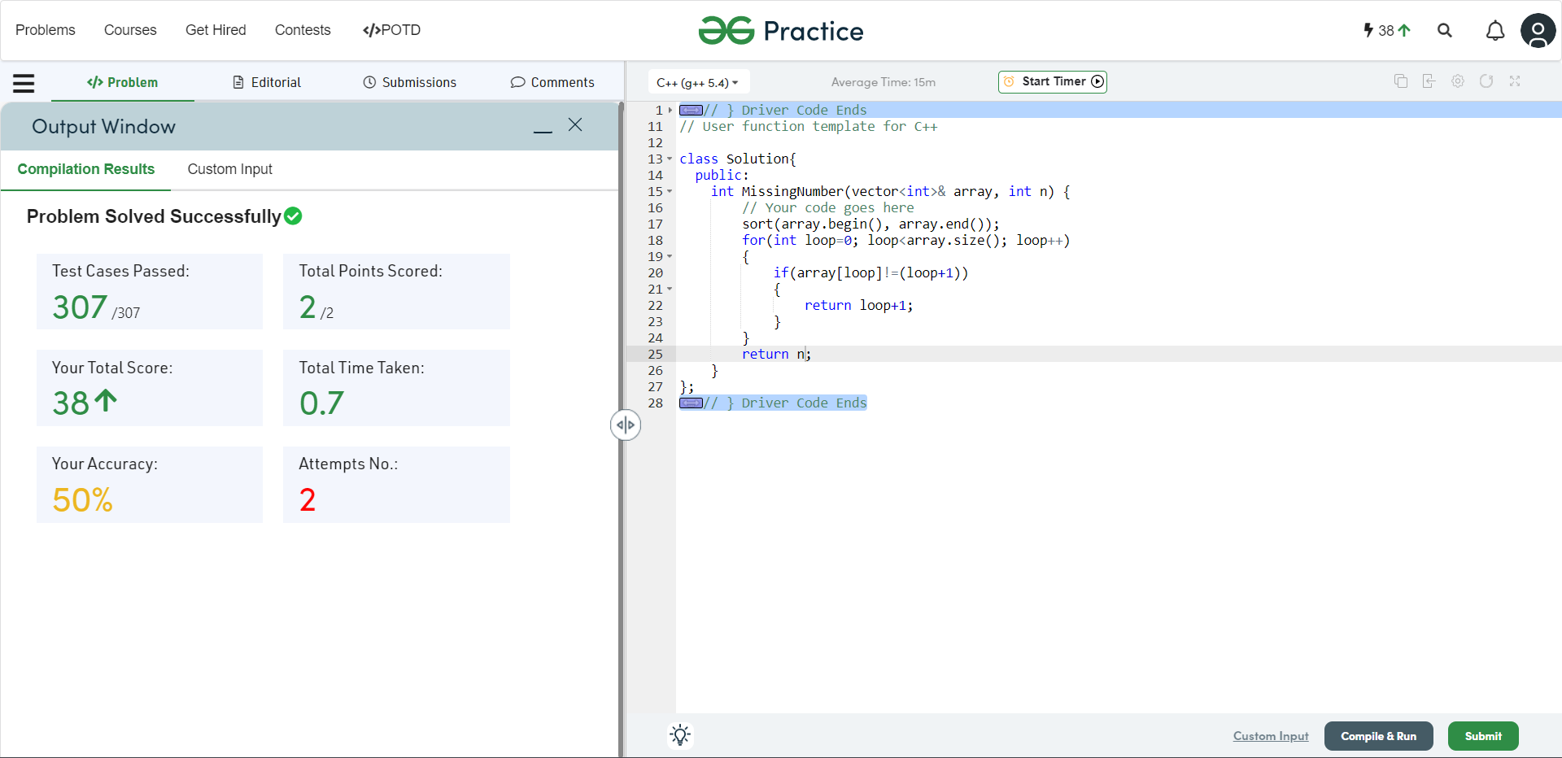

**Understanding about problem:**

In this task I need to return a number which is missing element of the array,array will contains number from 1 to N,N is length of array.

Note: If you can't understand the problem, feel free to contact us and we'll help you. Please don't copy and paste from anywhere.

ALL THE BEST

Team CP Club